- Write a SELECT statement that returns the same result set as this SELECT statement. Substitute a subquery in a WHERE clause for the inner join.
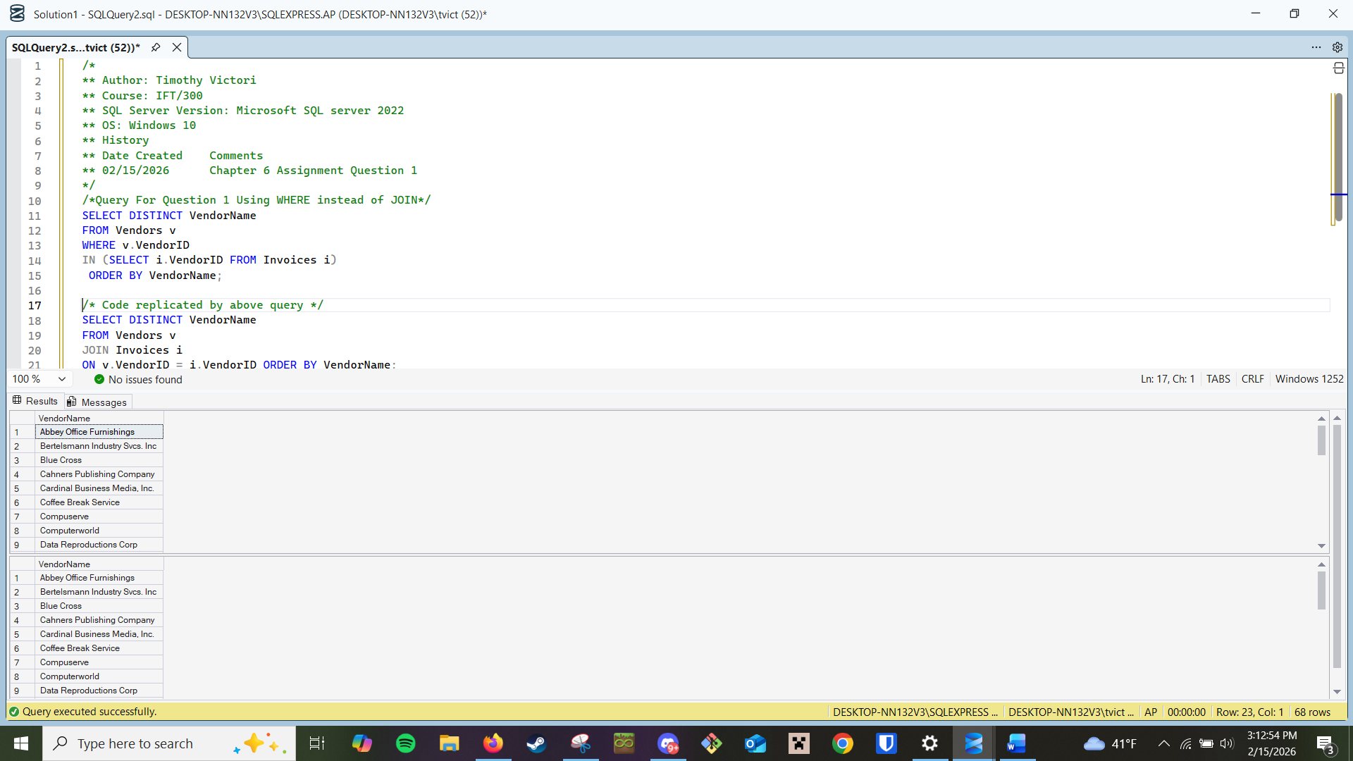
- Write a SELECT statement that answers this question: Which invoices have a PaymentTotal that’s greater than the average PaymentTotal for all paid invoices? Return the InvoiceNumber and InvoiceTotal for each invoice.
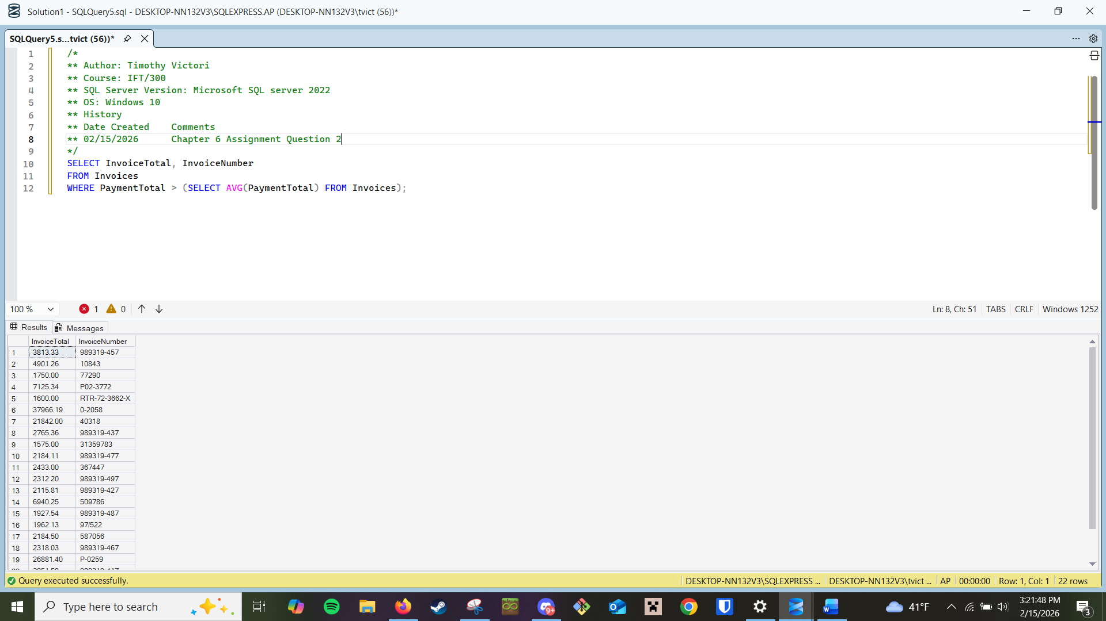
- Write a SELECT statement that answers this question: Which invoices have a PaymentTotal that’s greater than the median PaymentTotal for all paid invoices?
(The median marks the midpoint in a set of values. In other words, an equal number of values lie above and below the median value.) Return the InvoiceNumber and InvoiceTotal for each invoice
